Meta Description : RSF Packaging has created its name by providing its customers with quality-based packaging. They also provide exclusive gable boxes for their customers.

What You Should Know About the Unique Gable Boxes?
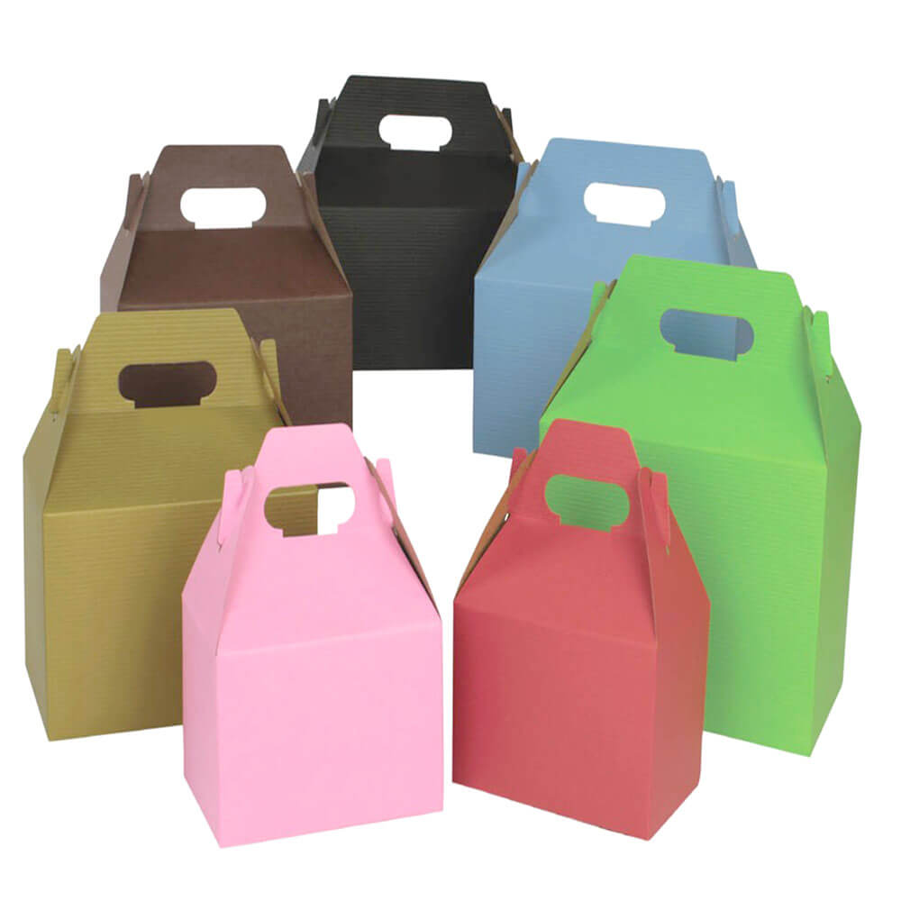

Gable boxes are the new eye-catching boxes that everyone wants for their business and also for personal use. They are also called the barn boxes. Because not only the food but one can store other things in these boxes too. The packaging company provides the gable boxes at wholesale. Their packaging is very handful and also very useful for the people. One can get the custom boxes as per their requirements. There are so many color options that they can choose from. The plenty of color option is because everyone wants to grow their business and brand. And wants customers to notice their brand through the packaging.
One might think that this is not a big deal. But the truth is it is a very big deal for small scale business. Because without some awesome factor they cannot maintain their image in the market. These boxes are used for different types of purposes. Such as if someone wants to pack their lunch in the boxes. Or want to gift the box to someone then they can wrap the gift in the boxes. And also if someone wants to store something for later use. Then these boxes should be their first preference.

The packaging company ensures its customers that it has been in the packaging business for decades. And knows the pros of the packaging and quality boxes in the market. If the outer atmosphere of the product is good. Then it surely will be liked by everyone. But if the look of the product is not up to the customer’s expectation. Then there is a high chance that the product may not be able to create its image in the market. And to fulfill the purpose for which the product was manufactured.

Important features of the boxes:

- The gable boxes are the containers. One can also use these boxes as a bag. They are one of the most versatile and striking packaging one can ask for.
- There are large boxes which the people mostly prefer to buy. There are so many benefits of the large boxes. And one can pack different things in the boxes. Such as they can pack gifts. If you go to the office daily then you can use these boxes as your lunch boxes. One can also market their business by providing necessary information about their company and details that a customer should be aware of.
- Different sizes are available in the boxes. One can custom the boxes and as well the shapes of the boxes. Their boxes are not specific for storing the food. But most people use it for this purpose.
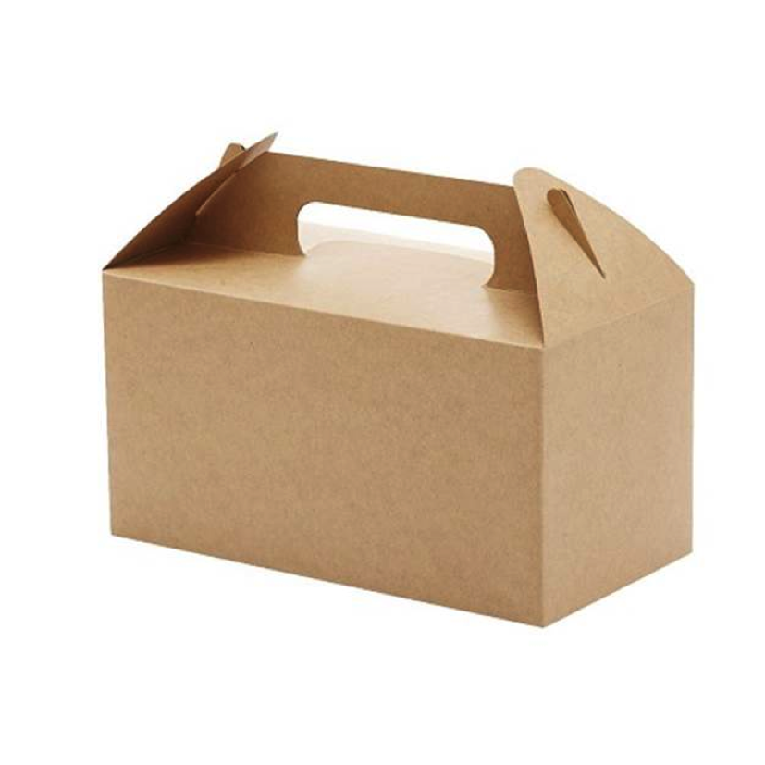
- One can customize the design and shape of the boxes according to their needs. The size of the boxes can also be custom made.
- The boxes mostly have a metallic finish. Which is very pleasant and eye-catchy.
- The packaging company also provides its customers the opportunity to add the name of their company or can add the design of the logo on the box. The company provides fully custom boxes to its customers.

Different type of gable boxes:
- Holiday gable boxes:
- Solid color gable boxes:

Holiday gable boxes:
Everyone knows the importance and happiness of the events and holidays. Everyone wants to spend these holidays with their friends and family. But when they go to visit their friends and family. People prefer to get some gifts for them. Those gifts can be packed in the holiday gift boxes. Which will be appealing to the customers. And also your loved ones will love them.

Solid color gable boxes:
The cute and exclusive solid color gable boxes are new in town. And also perfect for packing of different things. Such as gifts or even lunches. Not only the customers like these boxes but they will also look unique when you will carry them to wherever you are going.

Tags : Gable Boxes, gable boxes white, gable boxes large, gable boxes kraft, gable boxes wholesale, gable boxes hobby lobby, gable boxes bulk

